

**SPANWOOD FURNITURE PVT. LTD. Add: 55/A Dubay Nagar, Hudkeshwar Road, Nagpur-440034 📲 8830353363 | 7020296756**

**Merit 3d**

**Merit 2d**

[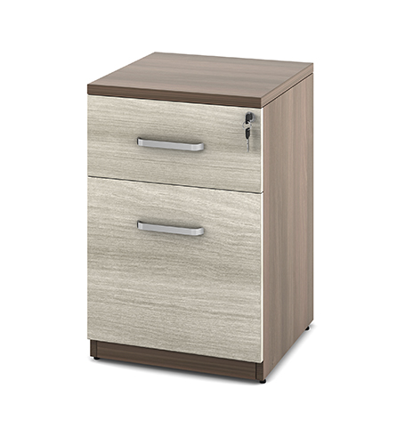](http://spanwood.com/) [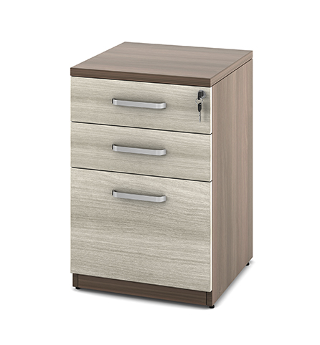](http://spanwood.com/)

**Merit-director-suite**

**MERIT mid-height1**

[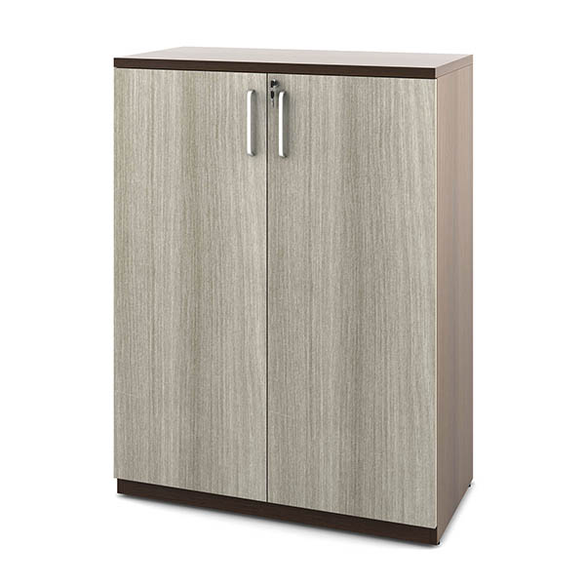](http://spanwood.com/) [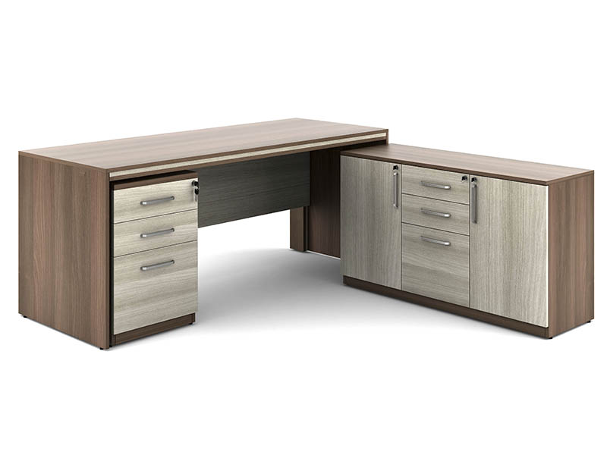](http://spanwood.com/)

<https://spanwood.com/>

**MERITmid-height-2**

**Merit-manager-suite**

[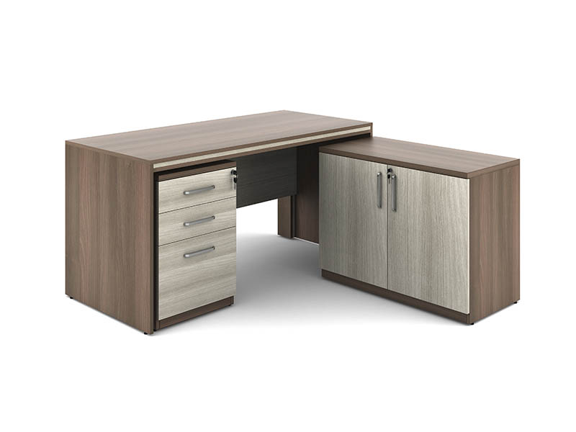](http://spanwood.com/) [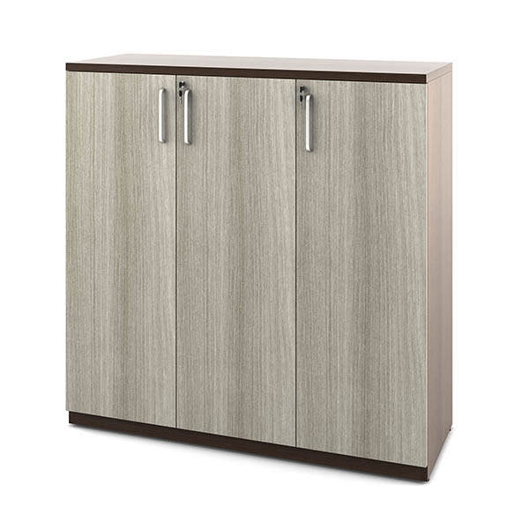](http://spanwood.com/)

**Mid-Height 1**

**Mid-Height**

[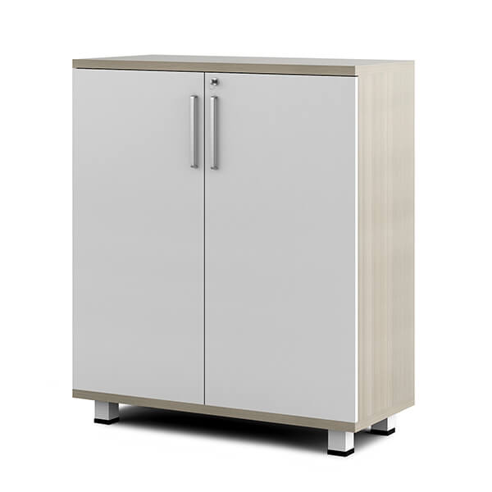](http://spanwood.com/) [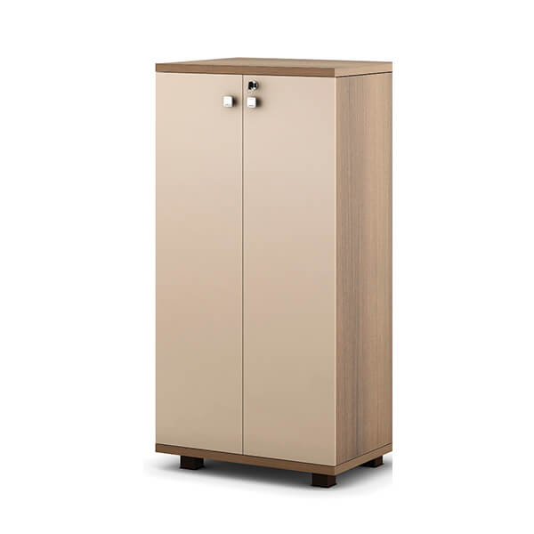](http://spanwood.com/)

**QUICK SHIP 3D**

**QUICK SHIP 1D**

[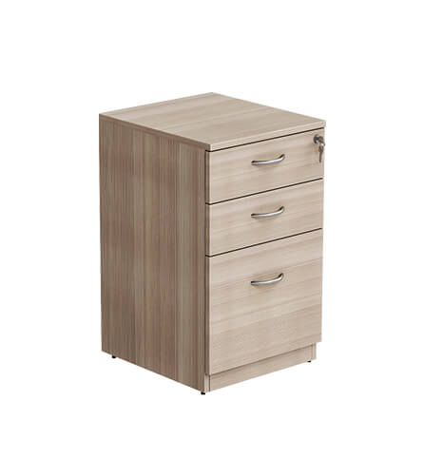](http://spanwood.com/) [](http://spanwood.com/)

**qs-mid-height-3**

**QUICK SHIP METAL 3D**

[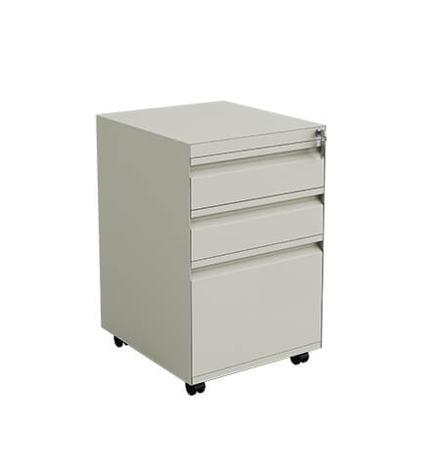](http://spanwood.com/) [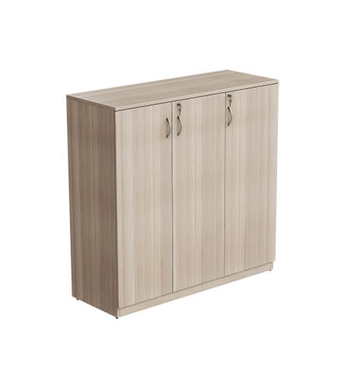](http://spanwood.com/)

<https://spanwood.com/>

**qs-mid-height-1**

**qs-mid-height-2**

[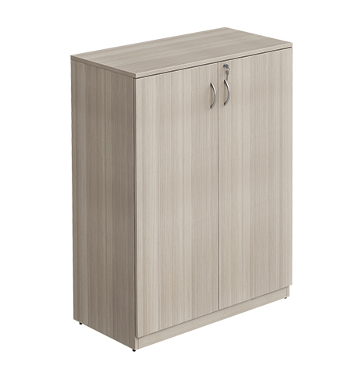](http://spanwood.com/) [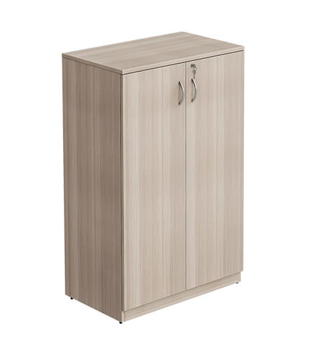](http://spanwood.com/)

**steel-storage-1**

**steel-storage-2**

[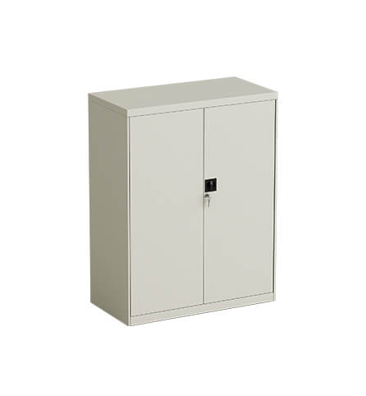](http://spanwood.com/) [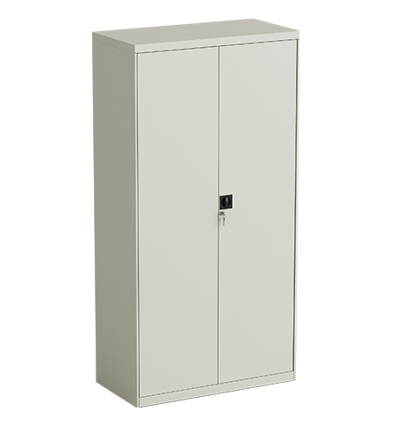](http://spanwood.com/)

<https://spanwood.com/>

**Steel-Storage**

**Steel-Storage**

[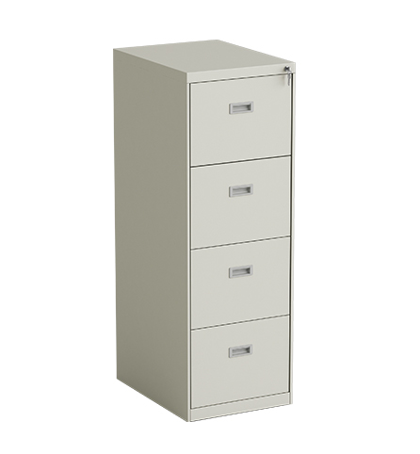](http://spanwood.com/) [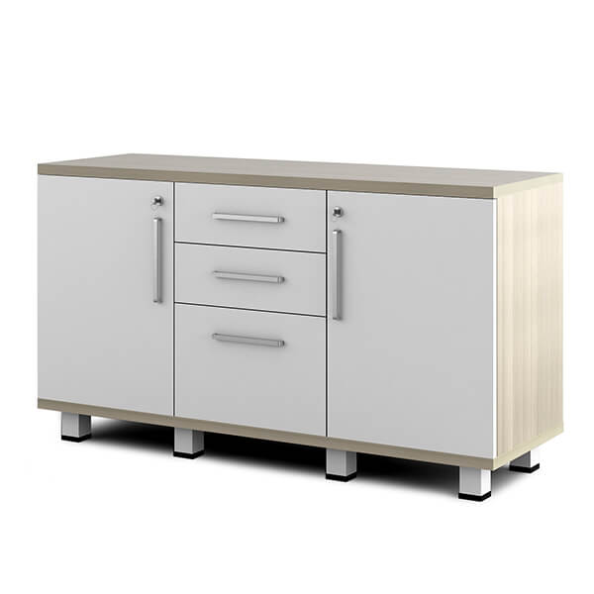](http://spanwood.com/)

**Spacewood**

**qs-workstation**

[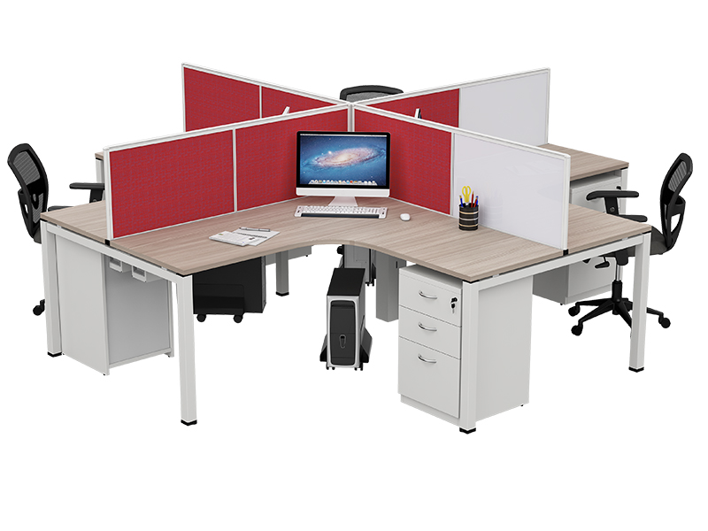](http://spanwood.com/) [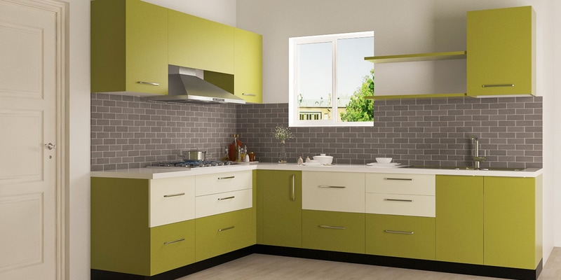](http://spanwood.com/)

<https://spanwood.com/>

**Mid-Height 2**

**Mid-Height 2D**

[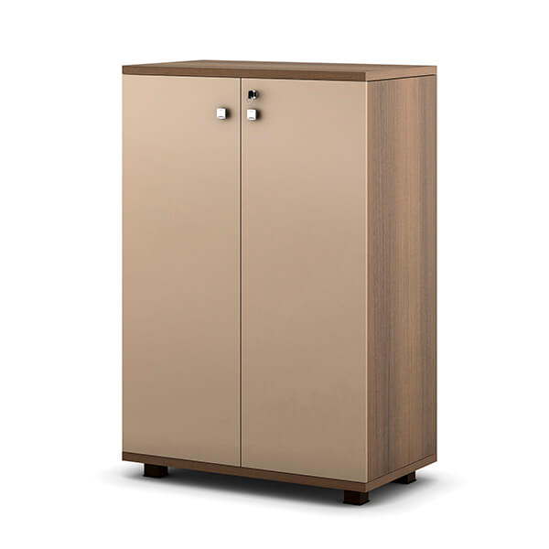](https://spanwood.com/) [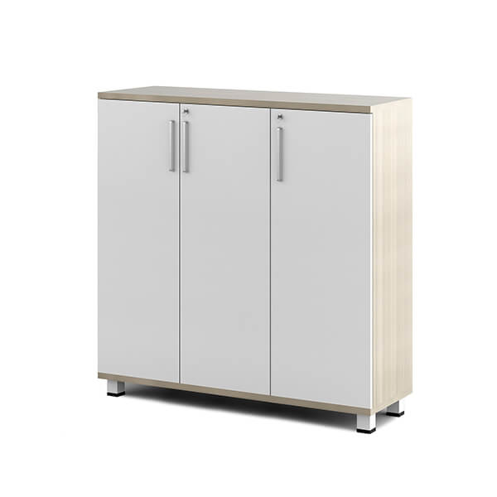](https://spanwood.com/)

**Mid-Height 3**

**Mid-Height 12**

[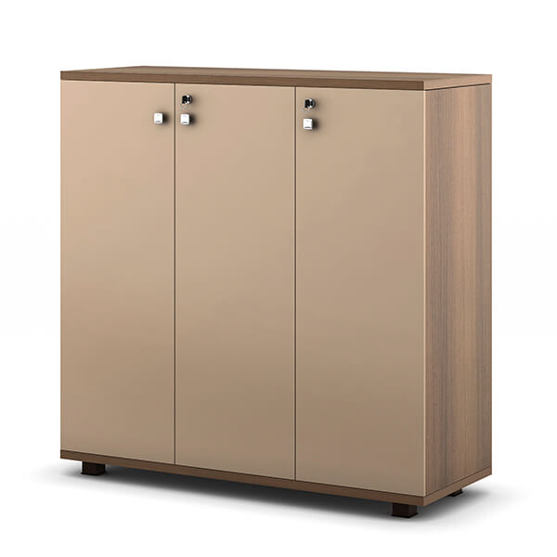](https://spanwood.com/) [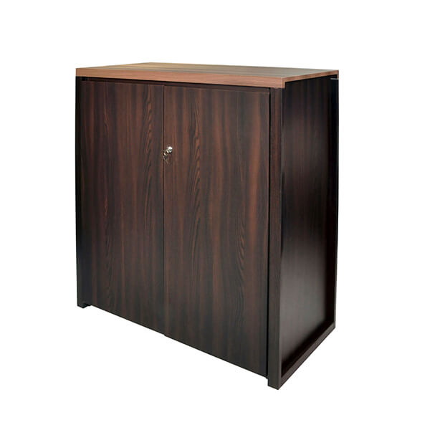](https://spanwood.com/)

<https://spanwood.com/>

**Mid-Height 21**

**Mid-Height-Storage-1**

[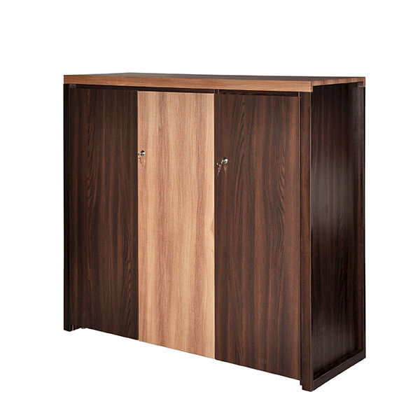](https://spanwood.com/) [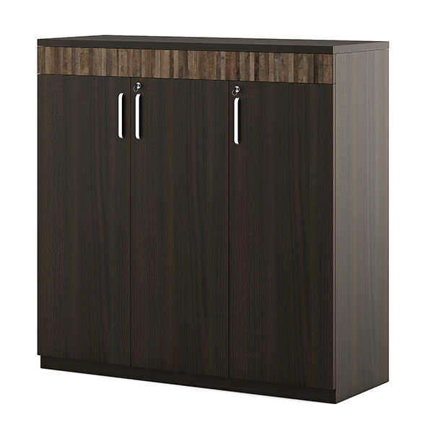](https://spanwood.com/)

**Mid-Height 21**

[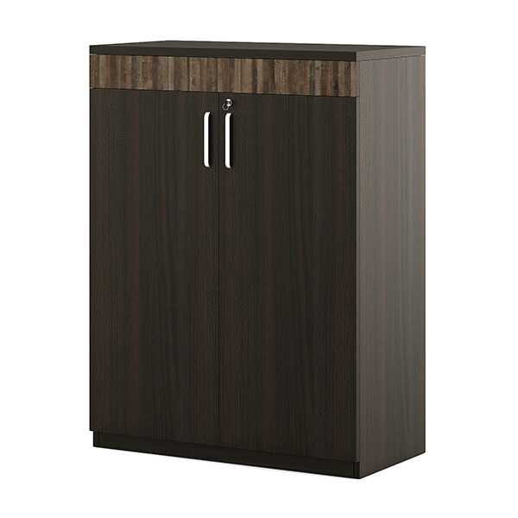](https://spanwood.com/)

<https://spanwood.com/>