

**SPANWOOD FURNITURE PVT. LTD. Add: 55/A Dubay Nagar, Hudkeshwar Road, Nagpur-440034 📲 8830353363 | 7020296756**

**Pedestals**

[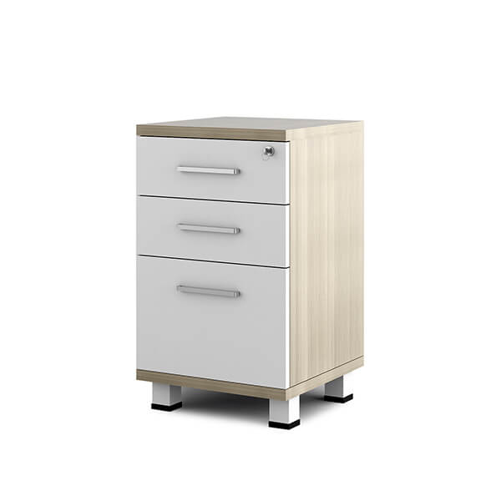](http://spanwood.com/) [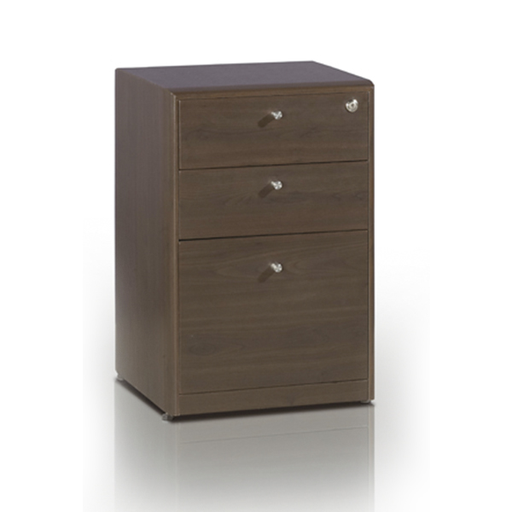](http://spanwood.com/)

[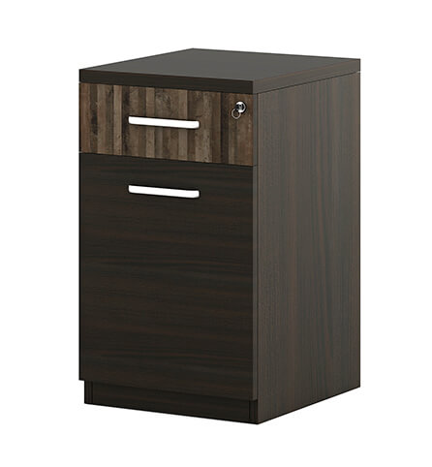](http://spanwood.com/) [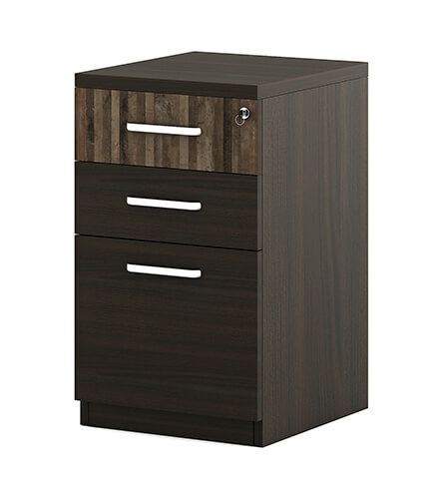](http://spanwood.com/)

<https://spanwood.com/>

**Pedestals**

[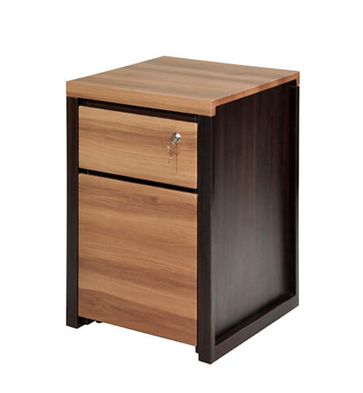](http://spanwood.com/) [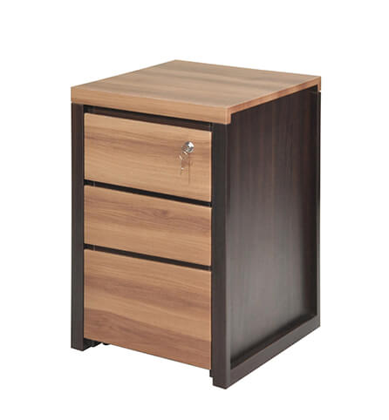](http://spanwood.com/)

[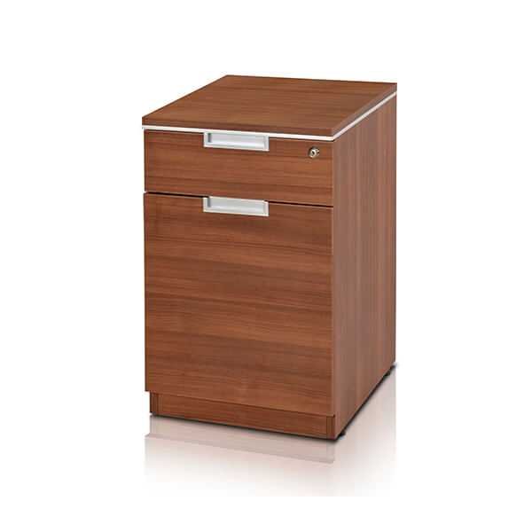](http://spanwood.com/) [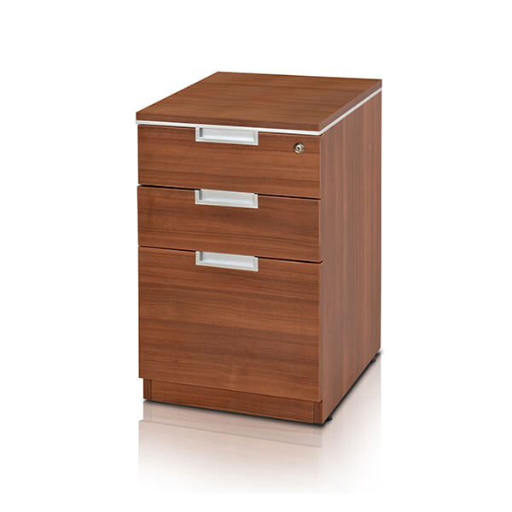](http://spanwood.com/)

<https://spanwood.com/>

**NOVA mid-height-2**

**NOVA mid-height-1**

[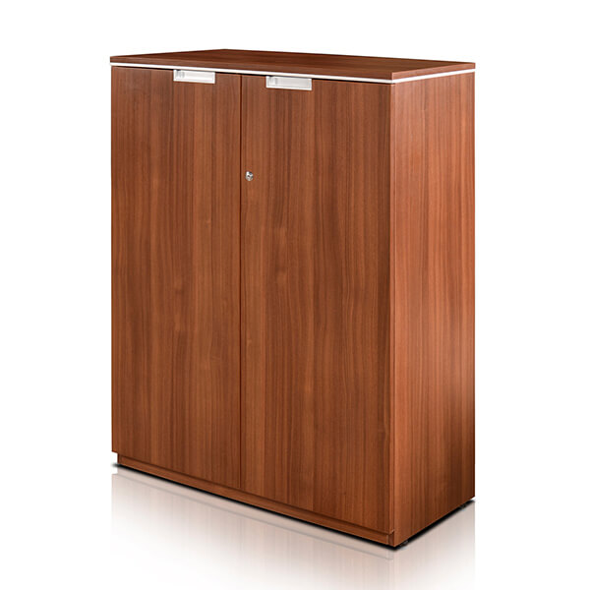](http://spanwood.com/) [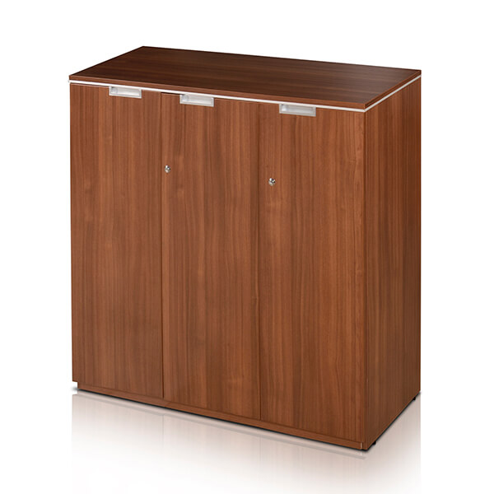](http://spanwood.com/)

<https://spanwood.com/>

**Nova-Manager-Suite**

**Nova-Director-Suite**

[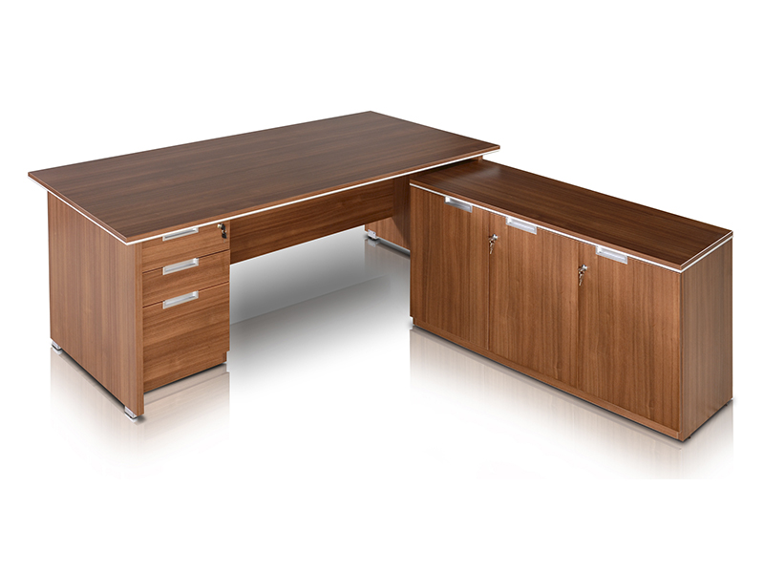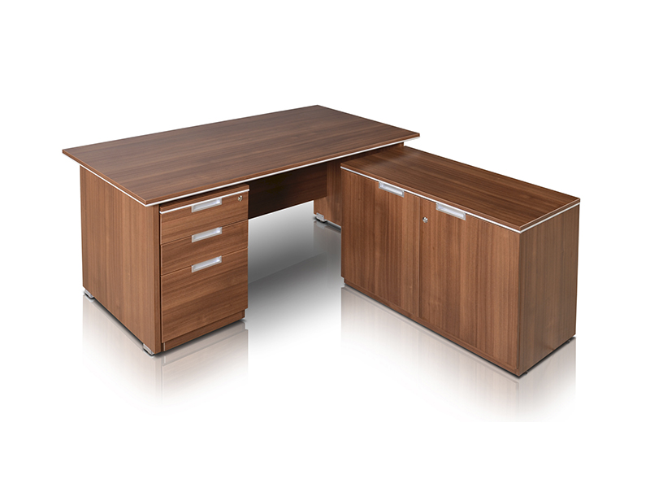](http://spanwood.com/)

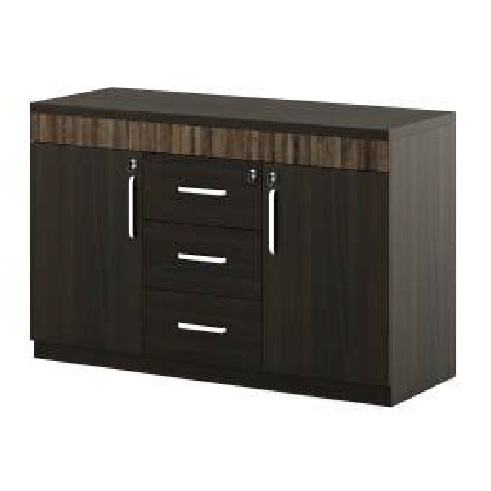 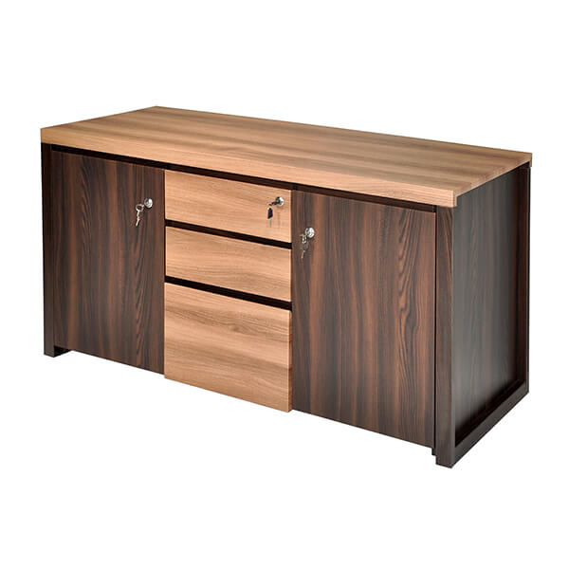

**Credestal 4**

**Credestal 3**

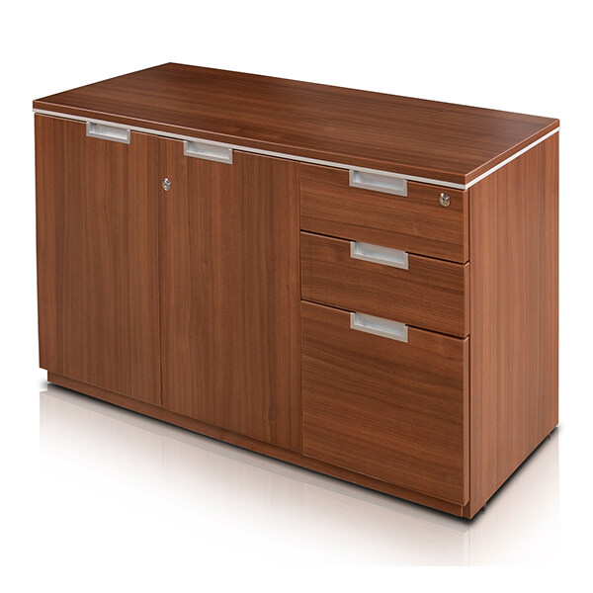 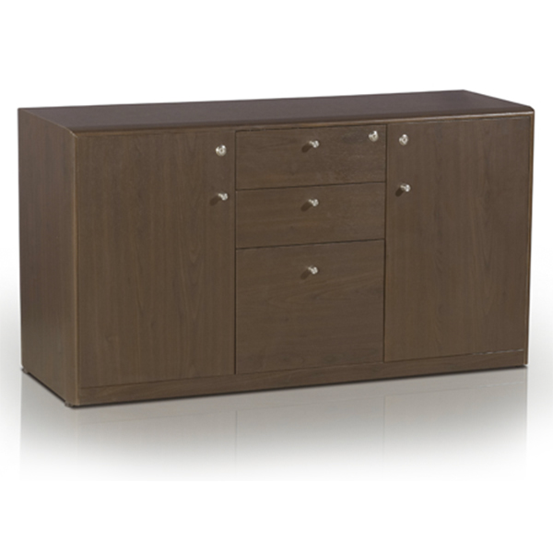

<https://spanwood.com/>

**Low-Height-1**

**Credestal 5**

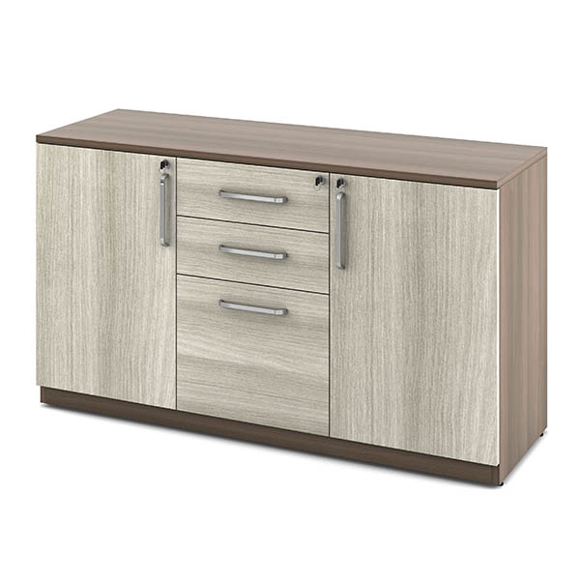 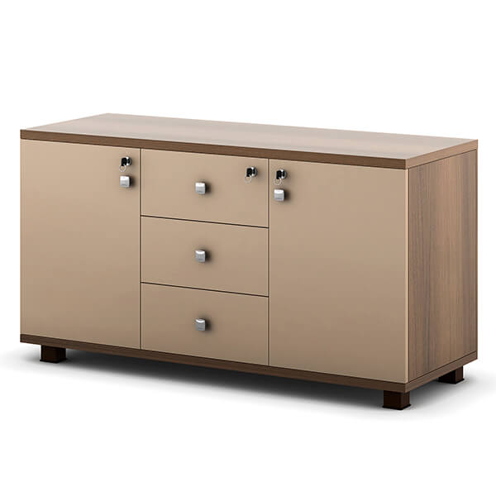

**Majestic-Manager-Suite**

**Majestic-Director-Suite**

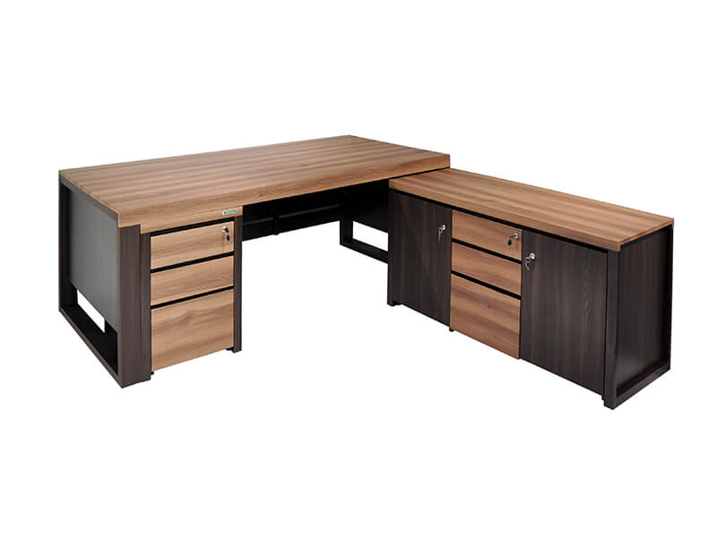 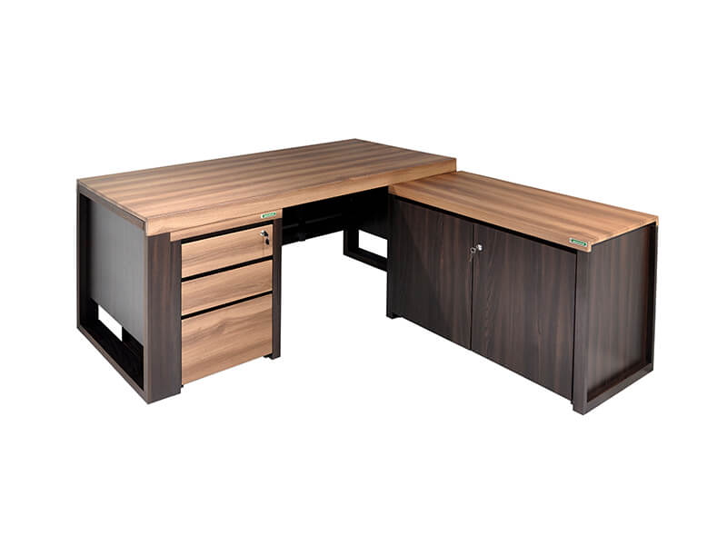

**Icon 1**

[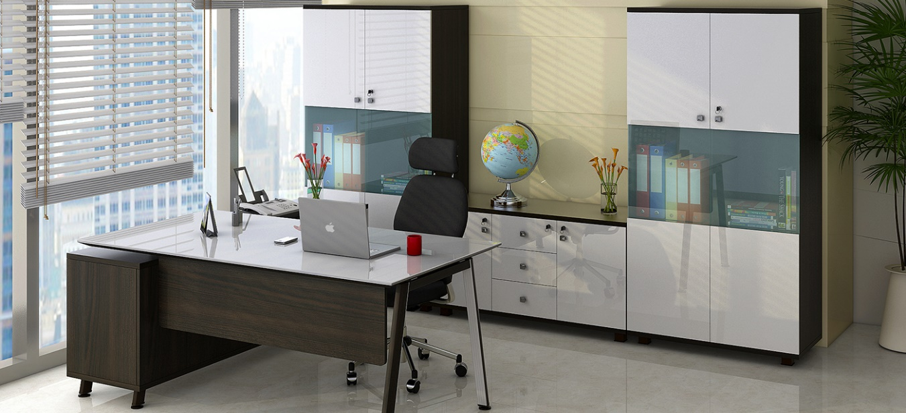](http://spanwood.com/)

<https://spanwood.com/>

**Icon-Director-Suite**

**Icon-Credestal**

[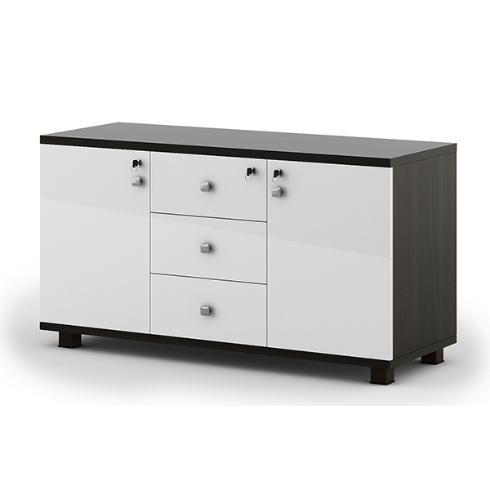](http://spanwood.com/) [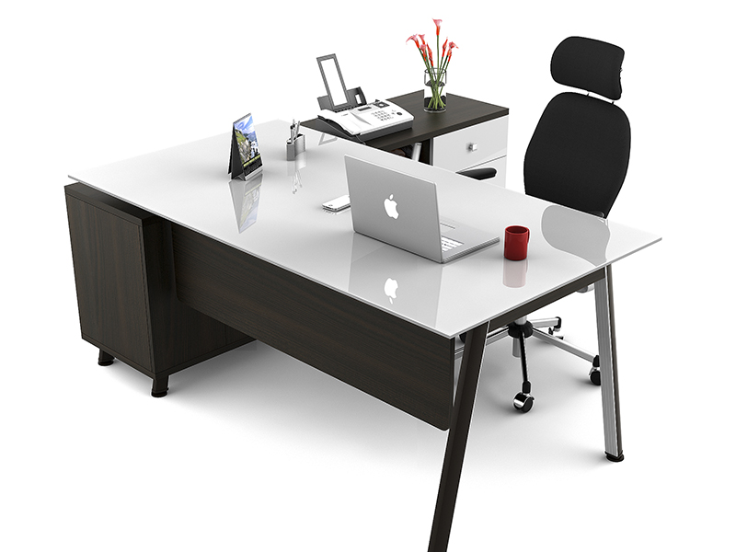](http://spanwood.com/)

**Icon-Mid-Height-1**

**Icon-Mid-Height-2**

[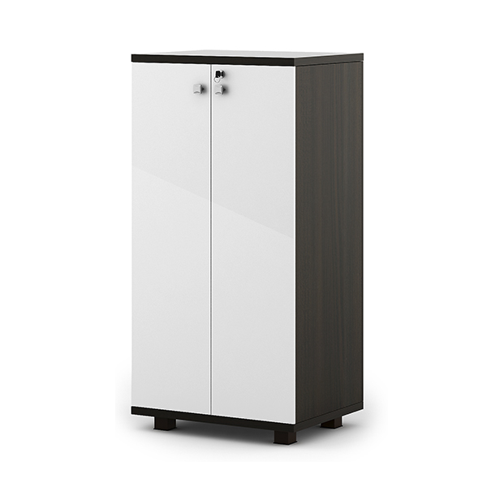](http://spanwood.com/) [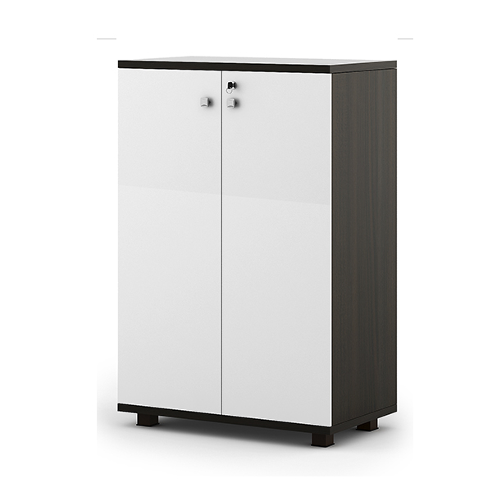](http://spanwood.com/)

<https://spanwood.com/>

**Icon-Mid-Height-3**

[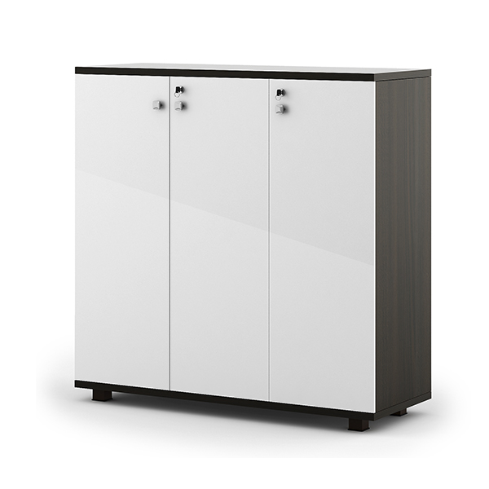](http://spanwood.com/)

**Prestige**

[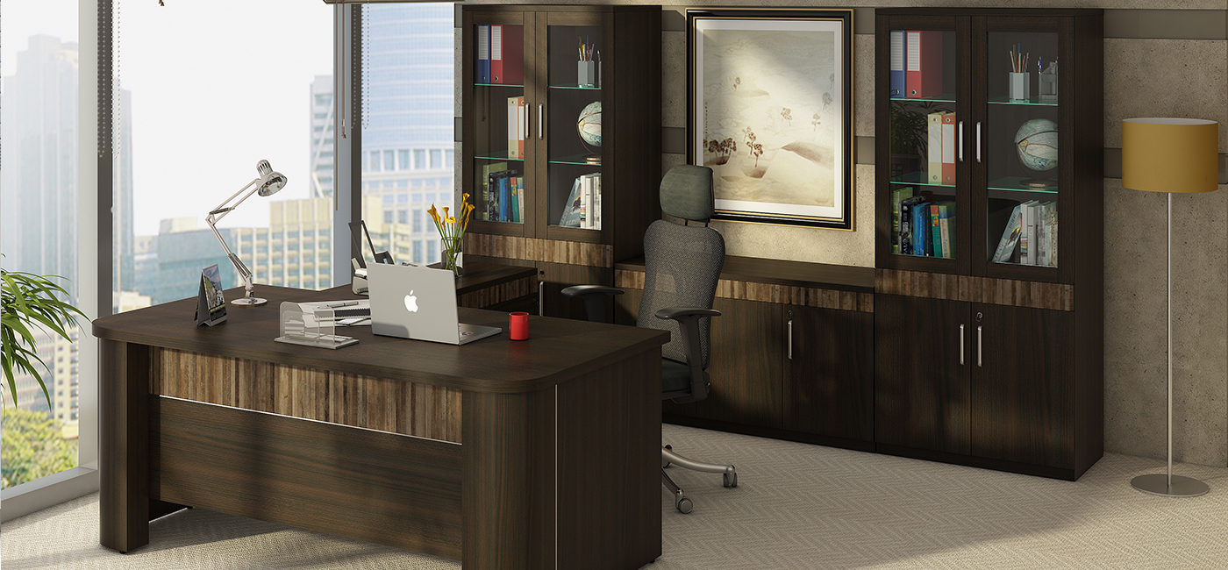](http://spanwood.com/)

<https://spanwood.com/>

**New Project**

[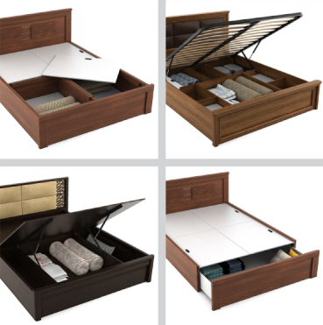](http://spanwood.com/) [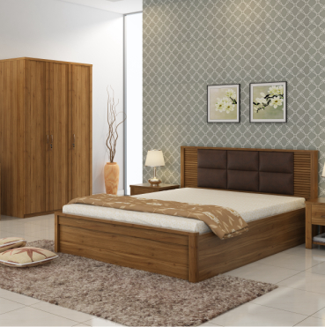](http://spanwood.com/)

**New Project**

[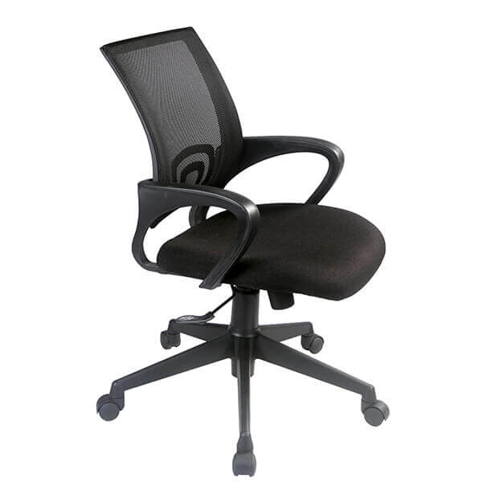](http://spanwood.com/)

<https://spanwood.com/>