

**SPANWOOD FURNITURE PVT. LTD. Add: 55/A Dubay Nagar, Hudkeshwar Road, Nagpur-440034 📲 8830353363 | 7020296756**

**Knigh-01**

**Knigh-02**

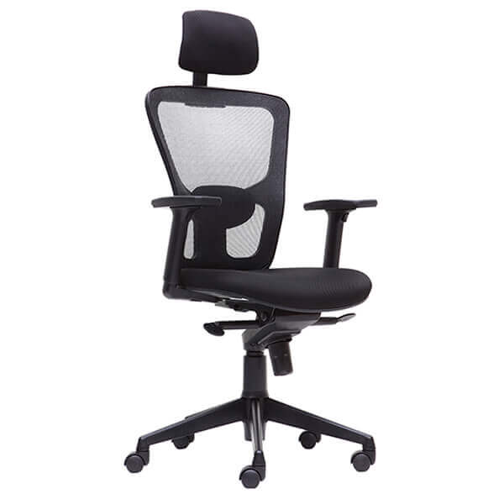 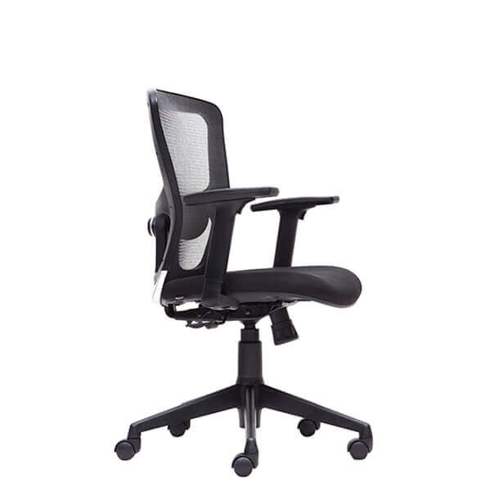

**Knigh-03**

**legion-Chair-1**

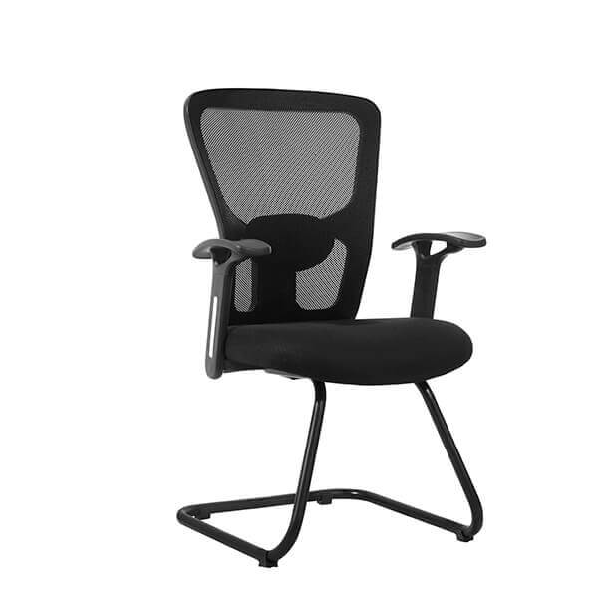 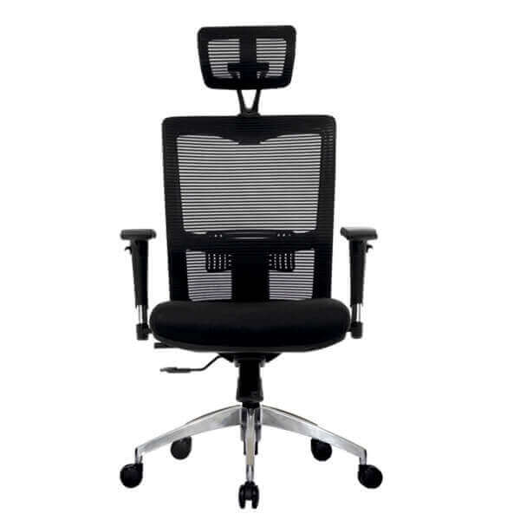

<https://spanwood.com/>

**legion-Chair-2**

**legion-Chair-3**

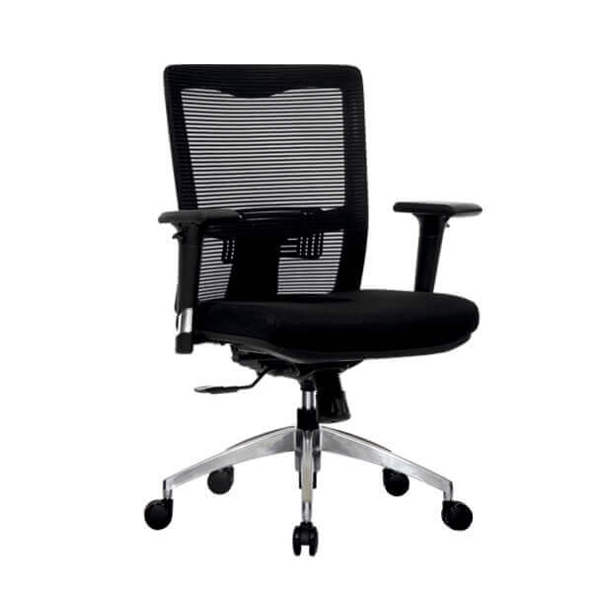 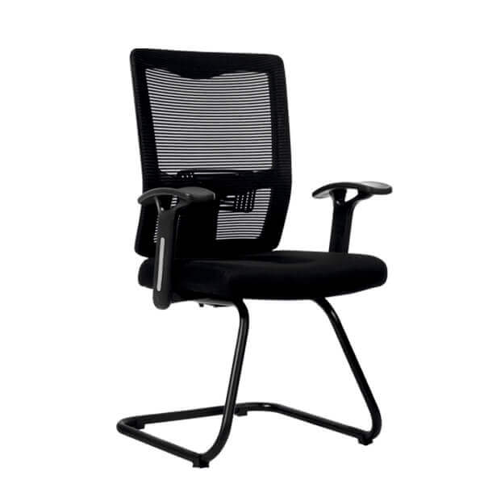

**Connect-Chair-1**

**Borron-Chair**

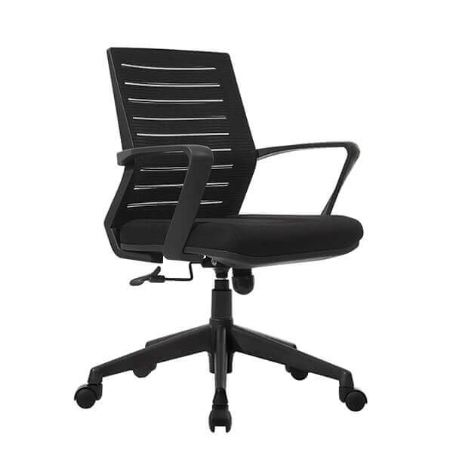 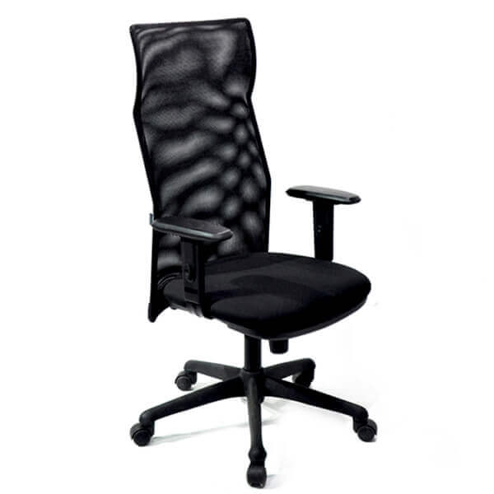

<https://spanwood.com/>

**Connect-Chair-3**

**Connect-Chair-2**

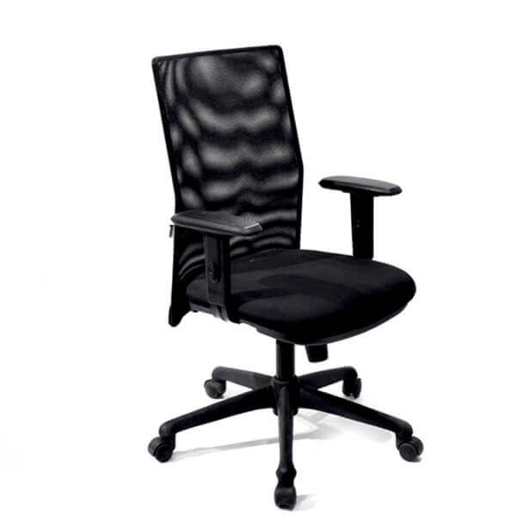 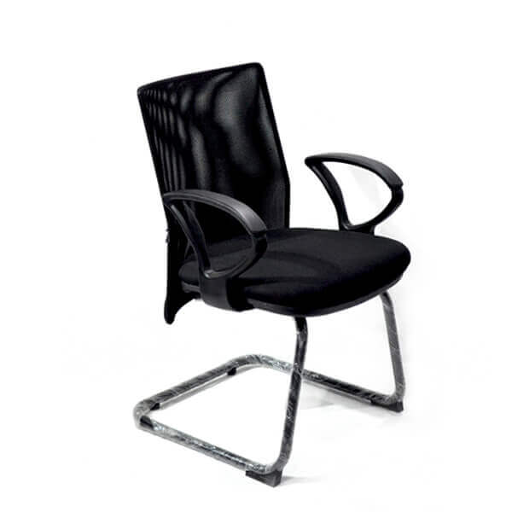

**Magnate-2**

**Magnate-1**

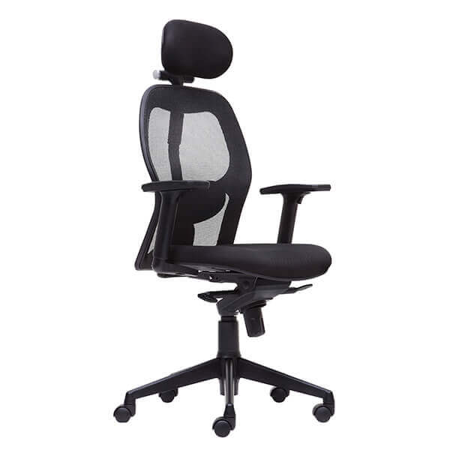 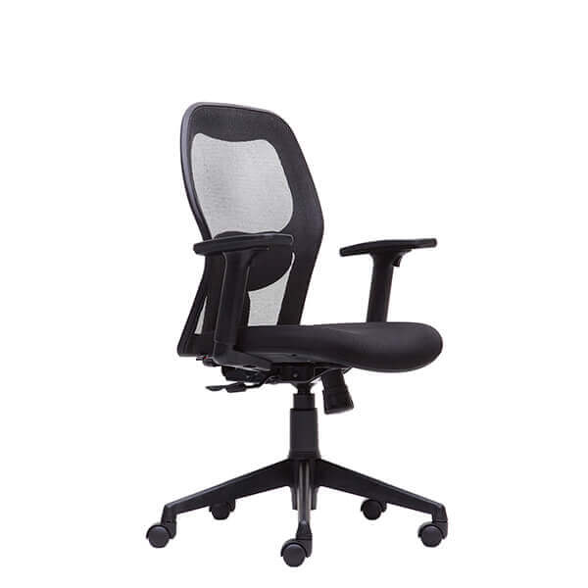

<https://spanwood.com/>

**Magnate-3**

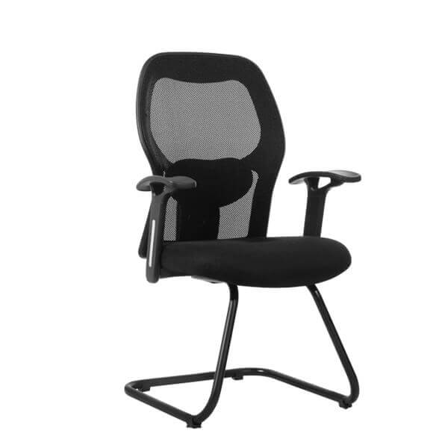

<https://spanwood.com/>