

**SPANWOOD FURNITURE PVT. LTD. Add: 55/A Dubay Nagar, Hudkeshwar Road, Nagpur-440034 📲 8830353363 | 7020296756**

**Table**

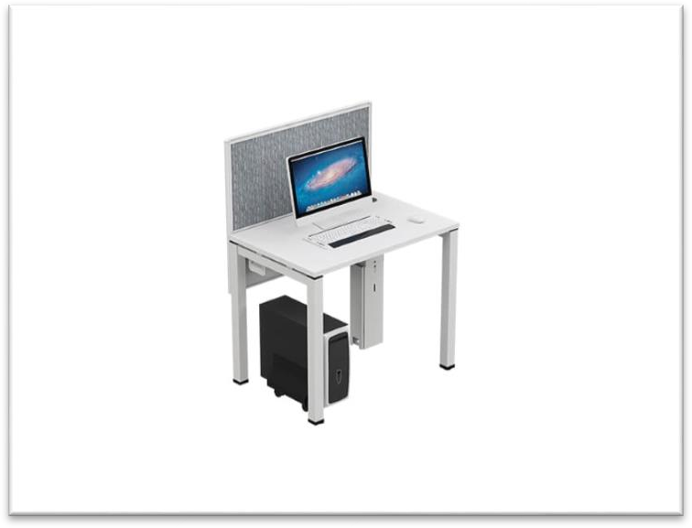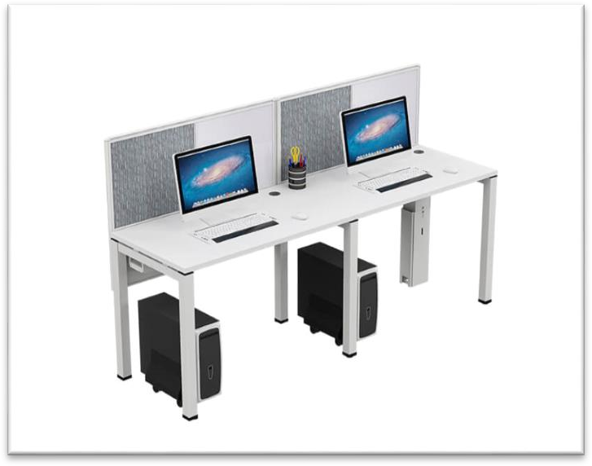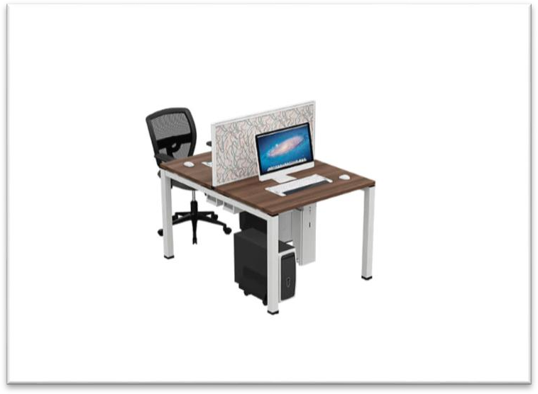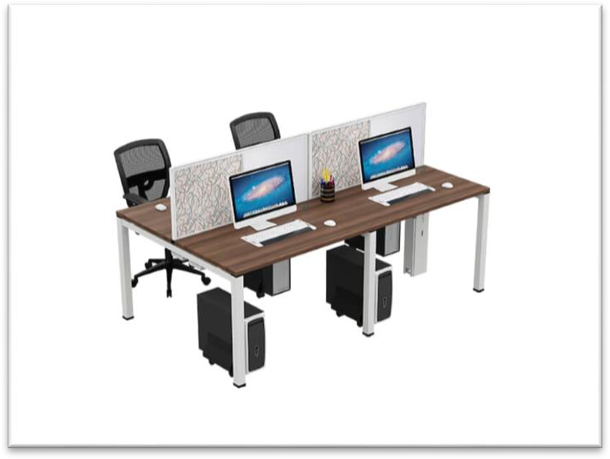

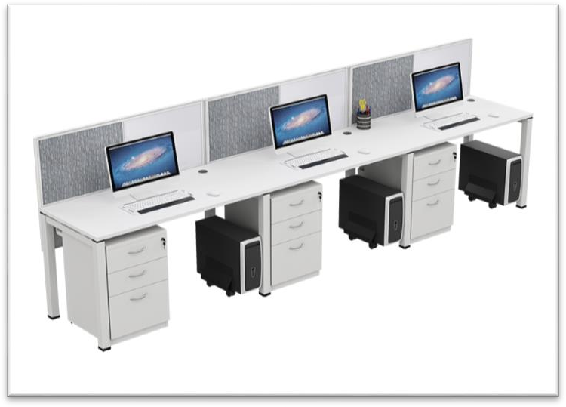 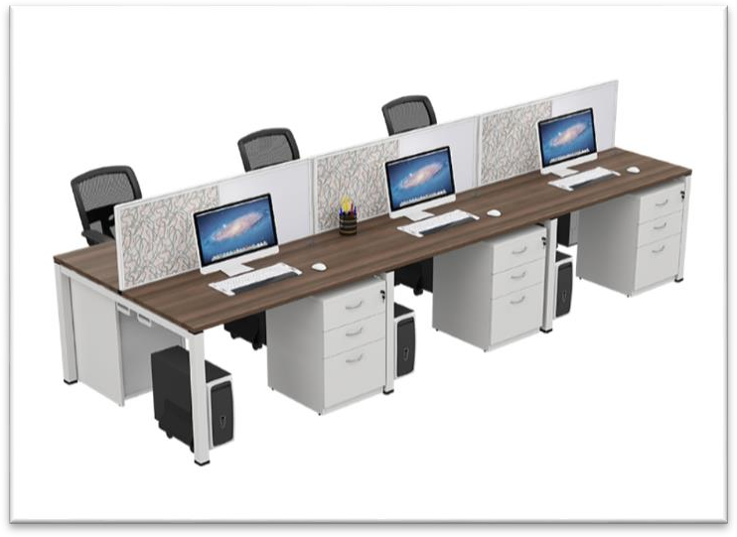

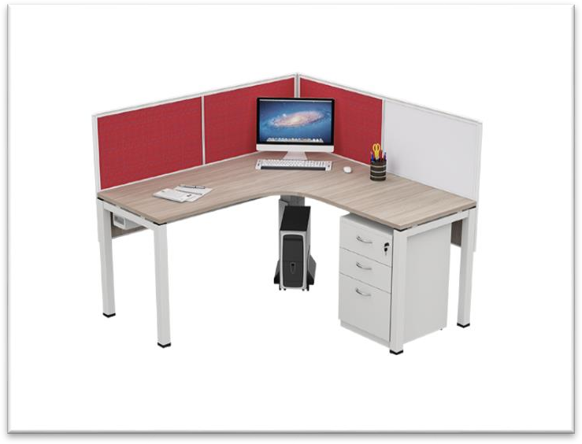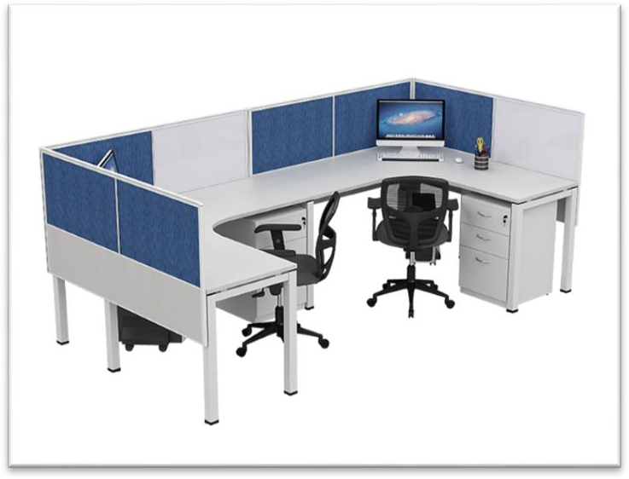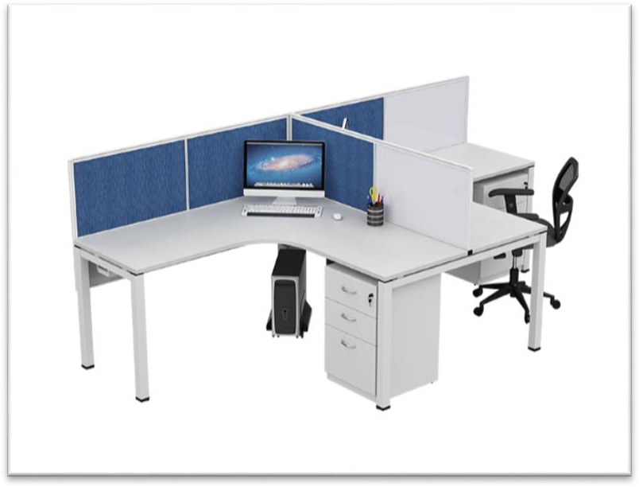

Estillo-Director-Suit

Estillo-Director-Suit

[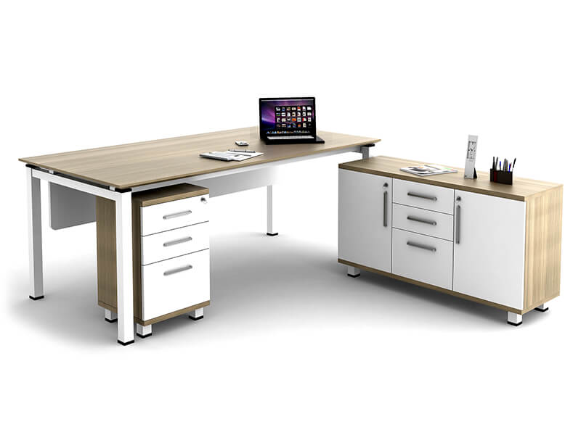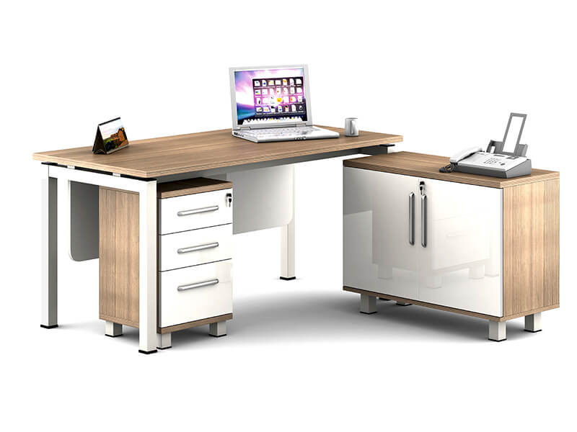](http://spanwood.com/)

Director-Suit

E Workstation Double Sided

[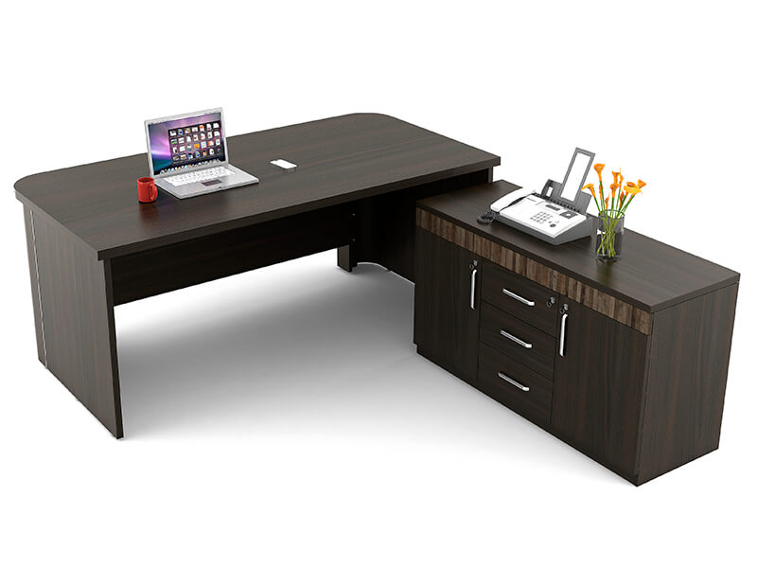](http://spanwood.com/) [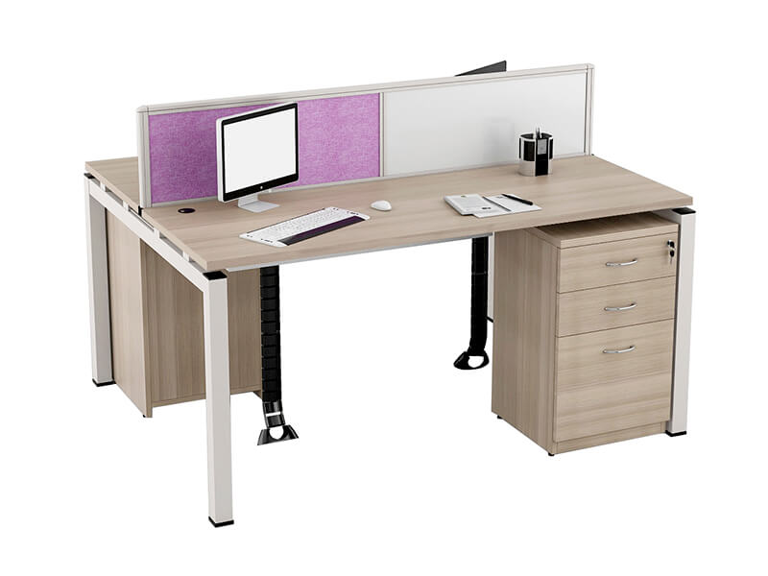](http://spanwood.com/)

<http://spanwood.com/>

E Workstation Plus

E Workstation Linear

[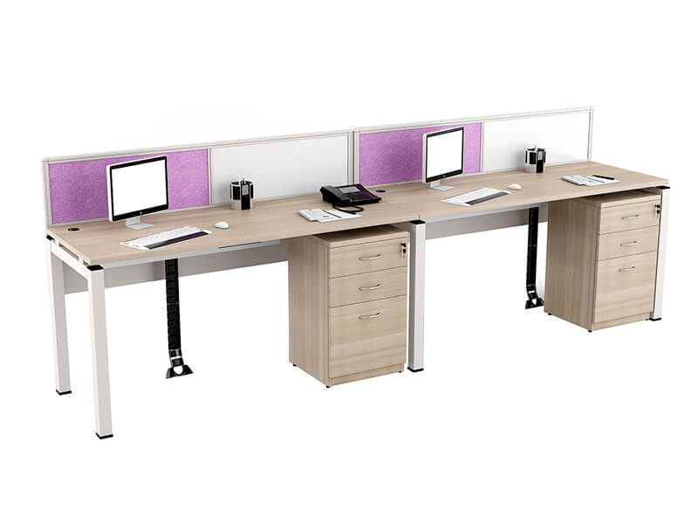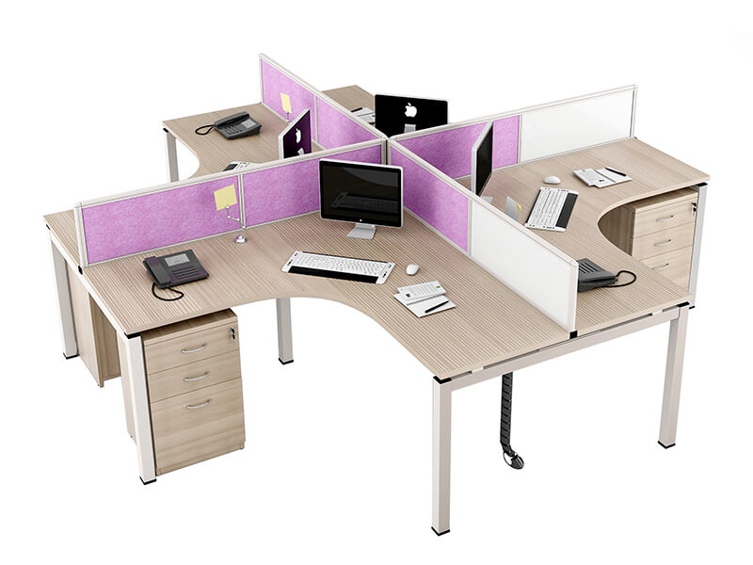](http://spanwood.com/)

E Workstation T Shape

[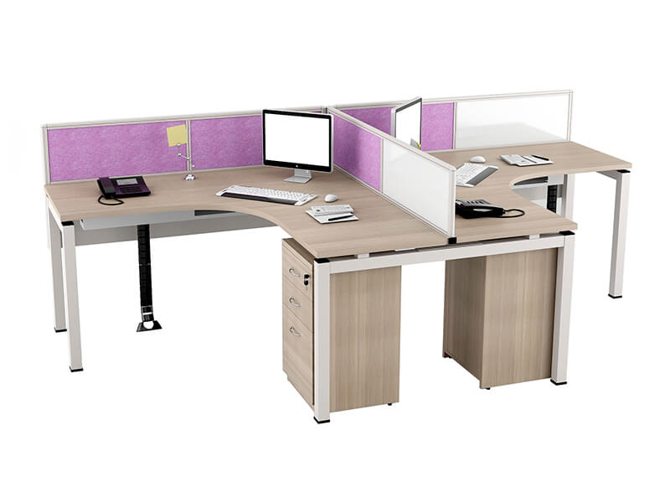](http://spanwood.com/)

**Z-Line Mid Height**

**Z-Linefull Height**

[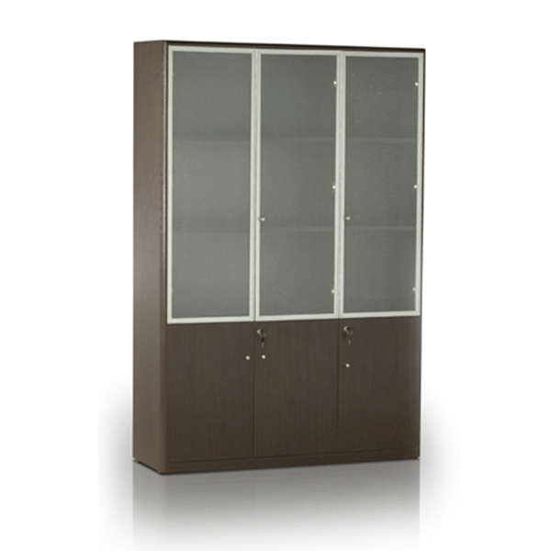](http://spanwood.com/) [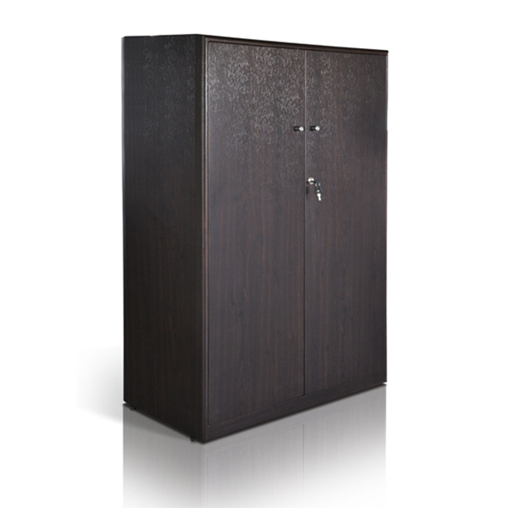](http://spanwood.com/)

**Z-Line Director Suit 1 111**

**Z-Line Mid Height 2**

[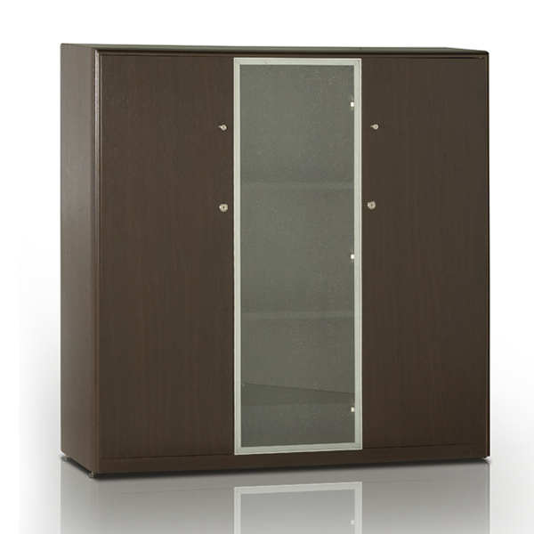](http://spanwood.com/) [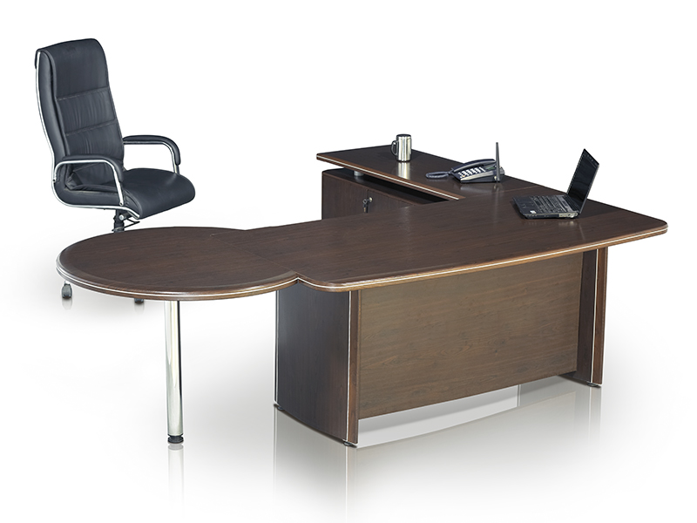](http://spanwood.com/)

**Z-Line Director Suit 2**

[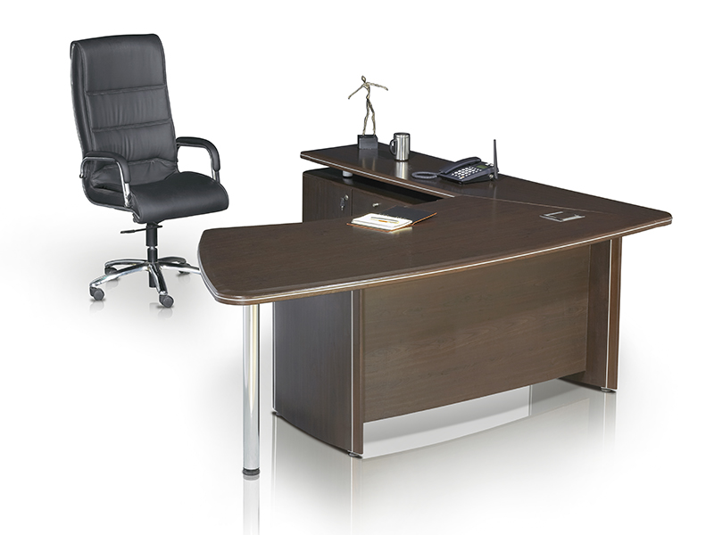](http://spanwood.com/)

**Z-Line Director Suit 2**

[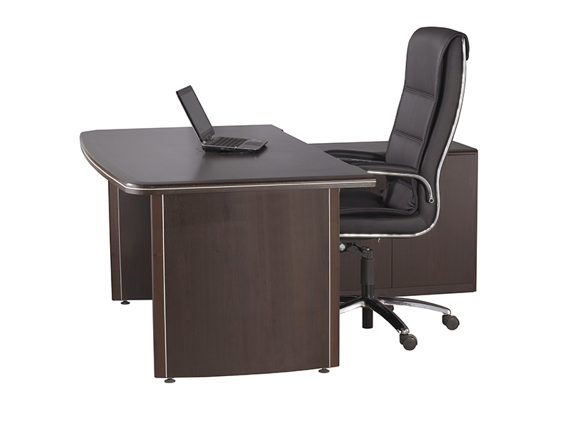](http://spanwood.com/)